How students create a PythonRoom account:
- Google- PythonRoom coding-> https://pythonroom.com/ , and click "Get Started" on the home page.
Or in the address bar type: https://pythonroom.com/join

- On the next screen, students should click the "join a classroom" option. and should NOT use the "join with Google" or "join by email" option.
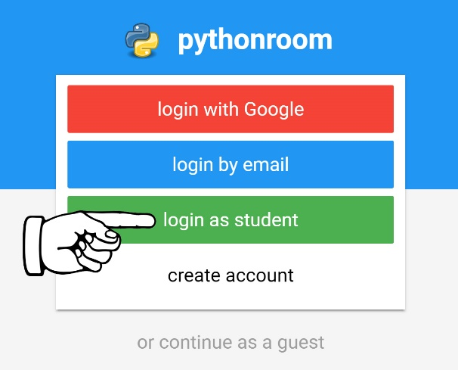
- Students should enter the name of the classroom:
“jedijillssteamlab”
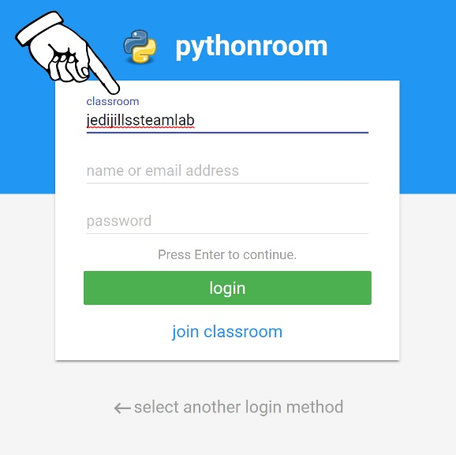

- Type your name on this line as the User Name
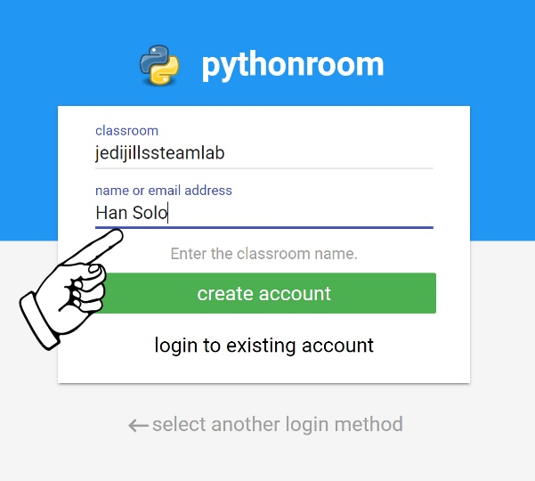
- Next, click "create account".
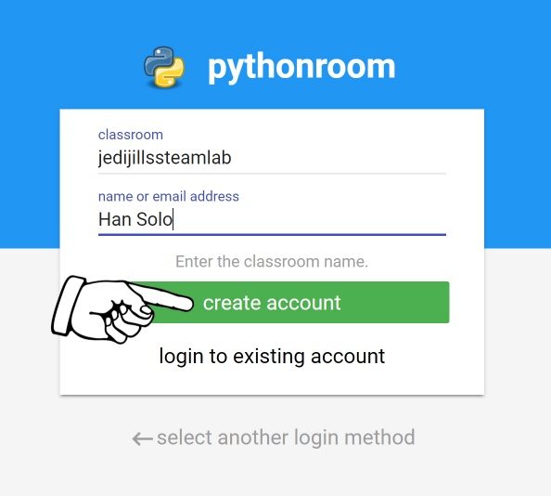

- Create a password for logging in for the first time, and click NEXT.
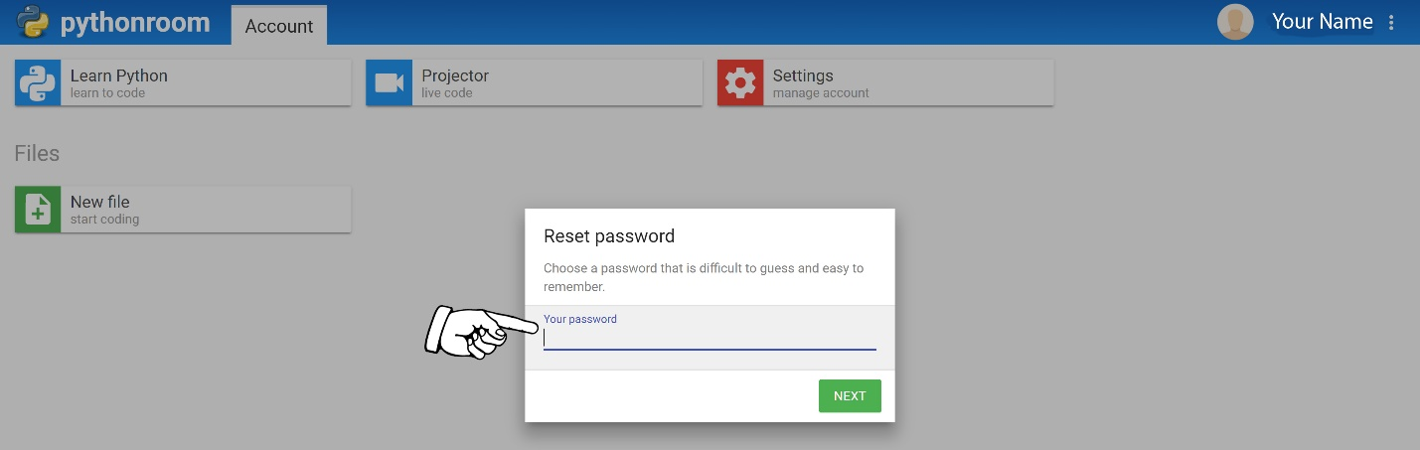

- Choose “Learn Python-learn to code”
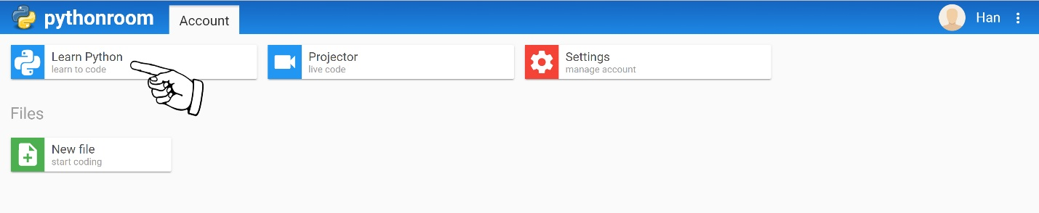
- Choose “Displaying output”, then read and follow each of the directions to complete this lesson.
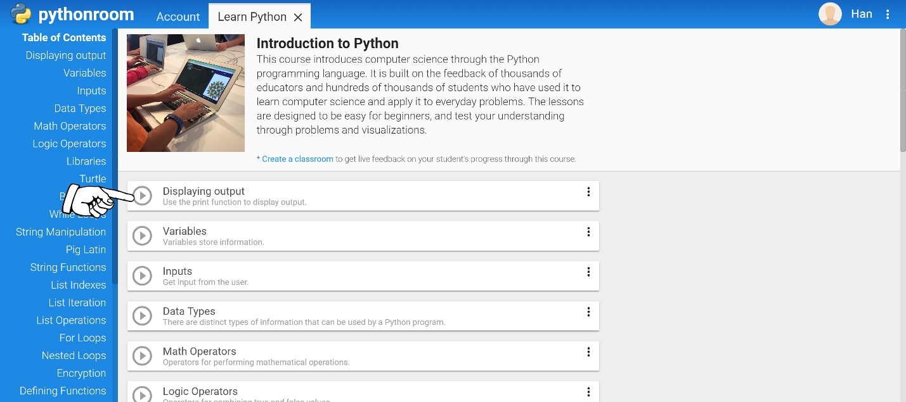
- After you have completed the first lesson in it’s entirety, move on to the next lesson and REPEAT until you have finished every lesson listed under the Table of Contents.
- To log in and complete lessons after logging out-- you enter the classroom name, your name, your password, and click “login.”
